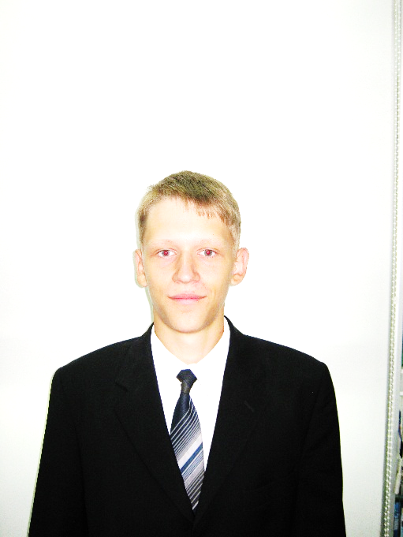**THE CURRICULUM VITAE**

**ALEKSANDR DOLINNIY**

**Personal Details:**

**Date of Birth:** 12\31\1995

**Marital status:** single

**Address:** 22 Yangelya Street

Kyiv 50000 Ukraine

**Phone: +**38 068 959 80 32

**E-mail:** [alex__dolinn@mail.ru](mailto:alex__dolinn@mail.ru)

|  |  |
| --- | --- |
| **Objective:** | Junior Programmer |
| **Education:**  2013-nowadays | National Technical University of Ukraine “Kyiv Polytechnic Institute”  Faculty of Informatics and Computing Technique |
| **Professional Skills:** | **Programming Language:** Java, Assembler  **Technology:** Java SE, Java EE,client-server  **Frameworks:** Spring, JSF, Hibernate  **IDE/Software Tools:** IntelliJ IDEA, Eclipse, Visual Studio  **Database Technologies:** MySQL, MongoDB  **Languages:** English, Ukrainian, Russian |
| **Personal skills:** | * team player skills; * leadership skills; * planning and organizing; * willing to learn; * ability to handle pressure and meet deadlines; * problem-solving; * adaptability and flexibility; * positive attitude and energy; |
| **Activities:** | Travelling, jogging, racing. |